**Generative AI POC**

**Introduction:**

It is a web-based document exploration application using Streamlit. This application is designed to function as a data explorer bot with question answering functionalities. Admin can upload various document formats (PDF, TXT, DOCX, XLSX, PPTX) and then interact with the bot to ask questions about the content of those documents.

**Prerequisites:**

* **Python interpreter** - Make sure the Python version is compatible with the libraries you're using (check the documentation for specific requirements).
* **Text Editor/IDE -** Using a code editor like Visual Studio Code or PyCharm can make the development process much easier.

Required packages/libraries to run the Data Explorer Bot application:

* streamlit
* PyPDF2
* langchain
* pandas
* pptx
* docx
* dotenv

**Features of Data Exploration Bot Application:**

* Supports uploading and processing of documents in formats such as PDF, text (TXT), Word (DOCX), Excel (XLSX), and PowerPoint (PPTX).
* Integrates AI-powered question-answering functionality to provide relevant responses to user queries.
* Differentiates between admin and normal user roles, enabling document management and interaction with the AI assistant.
* Implements a retry mechanism to handle rate limit errors when interacting with external services.
* Provides an intuitive user interface with interactive chat functionality for seamless user interaction.

**Application Workflow:**

* Admin logs into data explorer bot with the credentials of username and password.
* Admins can upload documents (like PDF, TXT, DOCX, XLSX, PPTX).
* The application processes uploaded documents, extracting text content.
* The admin/user can ask a question about the document content.
* The system searches the processed text using OpenAI's API to find relevant information.
* The user receives a response that summarizes the answer based on the documents.

**Implementation:**

1. **To Launch the Bot:** Run the Code (streamlit run <filename>.py)
   * It will Open your web browser and navigate to [Bot URL]. You'll find the Chat Search Bot interface.
2. **Choose Required Role:** They are 2 roles.
   * 1. Admin 2. User
   * Select either "Admin" or "User" based on your access level.

* If you choose **“Admin”**

1. **Admin Login (if applicable):** 
   * If you are an administrator, enter the user mail "admin" and password "admin@123" to authenticate. (**Note:** This is for secure authentication purposes). Click the Enter/login button to proceed.
2. **Upload Documents (Admin only):**

* Once logged in as an Admin, you can upload documents in various formats: PDF, TXT, DOCX, XLSX, or PPTX.
* Drag and drop files directly onto the interface or use the "Browse Files" option.

1. **Ask Your Questions:**
   * Enter your query in the designated field.
   * Click "Send" to send your question to the AI Assistant.
2. **Get Answers from the Assistant Bot:**
   * The AI Assistant will analyze your question and upload documents, then provide a response.
   * The conversation history including your questions and the bot's answers.

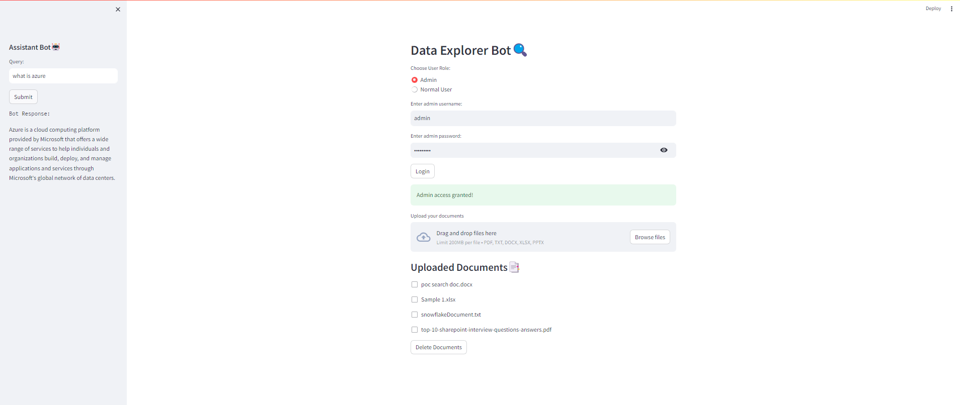

1. **Manage Documents (Admin only):**
   * Select the checkboxes next to documents you want to delete.
   * Click "Delete Documents" to remove them from the system.

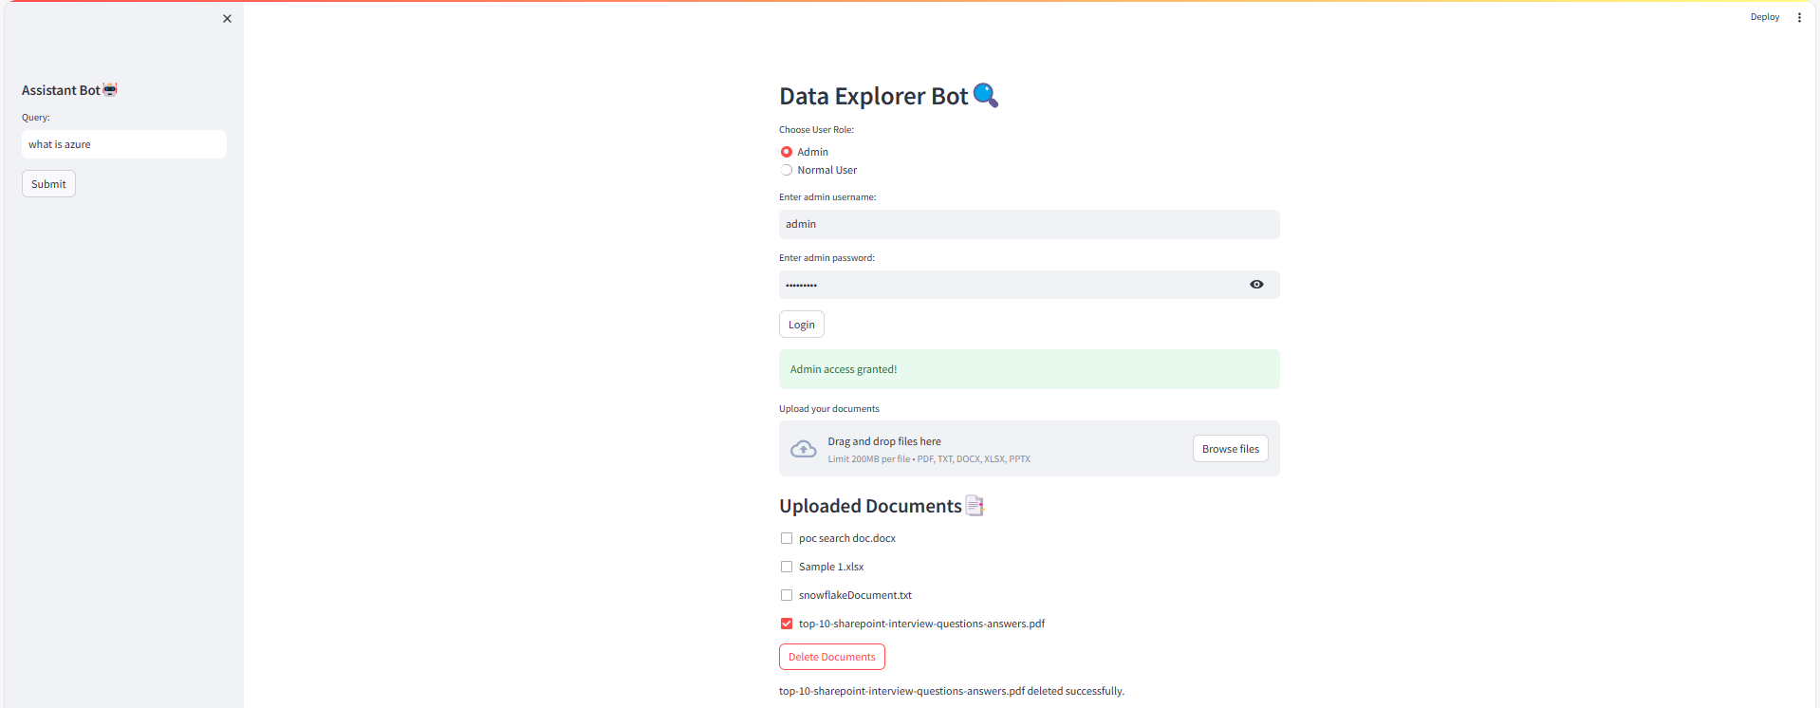

* If you choose **“User”**

If you're logging in as a normal user, you'll be able to view the list of uploaded documents.

1. **Ask Queries:**

* Enter your query into the input field on the right-hand side.
* Click the "Submit" button to submit your query.

1. **Get Answers from the Assistant Bot:**
   1. The AI Assistant will analyze your question and upload documents, then provide a response.
   2. The conversation history including your questions and the bot's answers.

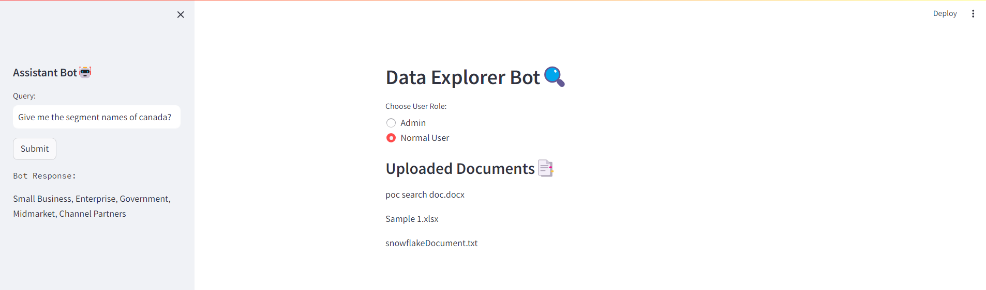

**Conclusion:**

The Data Explorer Bot represents a robust solution for document exploration and interaction, offering a seamless blend of document processing, AI-driven question answering, and user-friendly interface. Through its modular design and comprehensive functionality, the application empowers users to efficiently navigate and extract insights from various document formats.